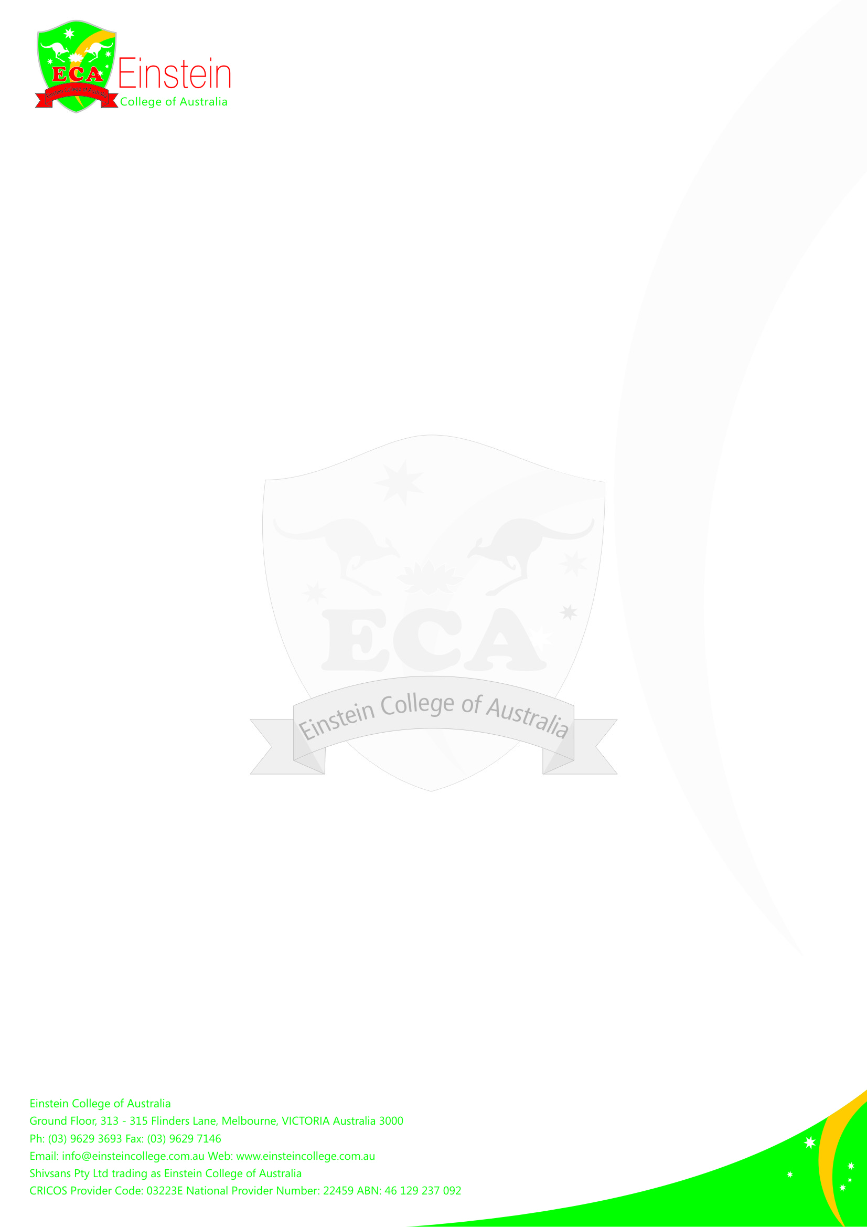
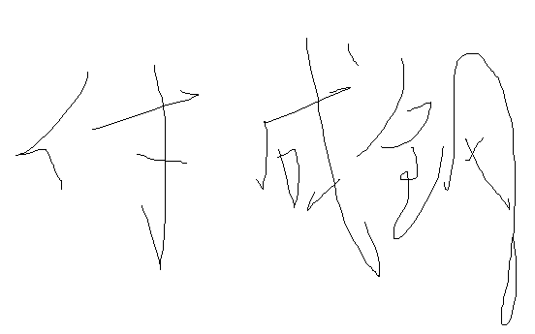
Employee Claim Time Sheet
Employee’s Full Name: CHENGGANG FU
Position: IT-Support
From Date: 01/11/2016 To Date: 30/11/2016
DateTime INTime OutSub TotalLess BreakTotal HoursStaff InitialMgr. Sign.07/Nov/201611:30AM
1:50PM12:00PM
8:10PM7 hours07 hours
14/Nov/20166:10PM9:00PM3.0 hours03.0 Hours
21/Nov/20166:25pm8:50pm2.5 hour02.5 hour
23/Nov/20166:30pm8:20pm2.0 hours02.0 hours
25/Nov/20166:15pm8:10pm2.0hours02.0hours
26/Nov/20161:30pm3:30pm2.0hours02.0hours

Total Claimed Hours18.50 Signature:
_Mgr. Signature:_______________________
Note: Please Attach Tax Invoice with the ABN prior to submission

